**Comsats University Islamabad**

**Abbottabad Campus**

***Information Security***

***Lab Task 2a***

**Name:** Malik Obaid Ur Rehman

**Reg no:** FA23-BCS-055

**Instructor:** Ma’am Fatime Hameed

Lab Task 3: For this exercise, you will keep track of when our friend’s birthdays are, and be able to find that information based on their name. Create a dictionary (in your file) of names and birthdays. When you run your program it should ask the user to enter a name, and return the birthday of that person back to them. The interaction should look something like this:

myDictionary={"ali":"1 nov","vali":"2 nov","hasan":"3 nov"

              ,"husan":"4 nov","olim":"5 nov"}

name=input("Enter name of your friend : ").lower()

print(f"the birthday is on {myDictionary.get(name,'not found')}")

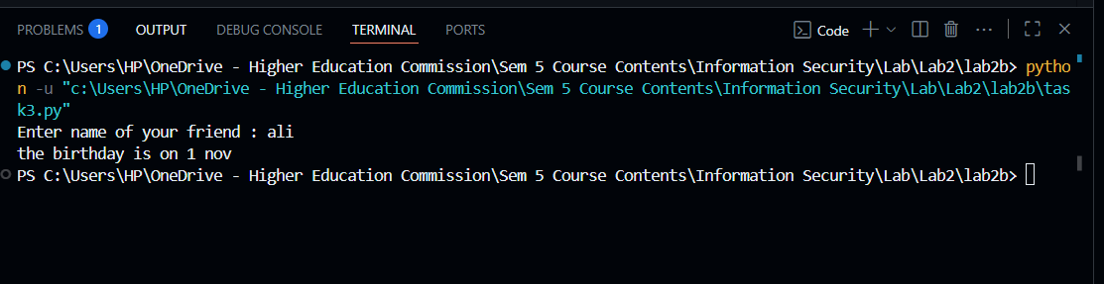

Lab Task 4: Create a dictionary by extracting the keys from a given dictionary Write a Python program to create a new dictionary by extracting the mentioned keys from the below dictionary.

sample_dict = {

"name": "Kelly",

"age": 25,

"salary": 8000,

"city": "New york"}

keys = ["name", "salary"]

new_dict = {k: sample_dict[k] for k in keys}

print(new_dict)

